City of White Plains
e
2021 Communitywide Greenhouse Gas
Emissions Inventory



This is an update of the Original 2010 Mid-Hudson Regional Greenhouse Gas Emissions
Inventory Final Report.

In 2012, New York State conducted regional GHG emissions inventories for the baseline year 2010, which included emissions for each community in the Mid-Hudson Region.

Prepared for:
New York State Energy Research and Development
Authority (NYSERDA)
17 Columbia Circle
Albany, New York 12203-6399

Prepared by:
ICF International, Sub-consultant to VHB, Inc.
December 13, 2012



In 2023, with support from the NY Department of Environmental Conservation Climate Smart Communities Coordinator Funding, the inventory was updated by Hudson Valley Regional Council (HVRC) using 2020, 2021, and 2022 data with support from Climate Action Associates. We have described the reason why a specific year was chosen in the methods of each sector.

This data update followed the established methodology from the 2010 Mid-Hudson Regional Inventory and the 2015 New York Community and Regional GHG Inventory Guidance. The GHG emissions for all communitywide activities are measured in metric tons of carbon dioxide equivalents (MTCO2e) and were calculated using emissions factors by the US Energy Information Administration (EIA), US Environmental Protection Agency (EPA) and ICF International / NYSERDA GHG Inventory Tool.


Prepared by


Melanie Patapis
Climate Smart Coordinator
Hudson Valley Regional Council

105 Ann Street, Ste2
Newburgh, NY 12550
Phone: 845-564-4075
Email: mpatapis@hudsonvalleyrc.org

List of Acronyms and Abbreviations

ACS American Community Survey
ANDOC Anaerobically degradable carbon
BOD₅ 5-day biological oxygen demand
BTU British thermal units
eGRID Emissions & Generation Resource Integrated Database
EIA Energy Information Administration
EPA Environmental Protection Agency
FOD First-order decay
GHG Greenhouse gas
GHGRP Greenhouse gas Reporting Program
C&D Construction and demolition
CH₄ Methane
CO Carbon Monoxide
CO₂ Carbon dioxide
HDD Heating degree days
HFCs Hydrofluorocarbons
HU Housing units
IPCC Intergovernmental Panel on Climate Change
LFG Landfill gas
LFGTE Landfill gas to energy
LUAF Lost and accounted for
LULUCF Land use, land use change, and forestry
Mcf Thousand cubic feet
MF Multi-family
MMBTU Million British thermal units
MSW Municipal solid waste
MTCO₂e metric tons carbon dioxide equivalent
MWh Megawatt-hour
N₂O Nitrous oxide
NAICS North American Industry Classification System
NASS National Agricultural Statistics Service
NYCW NPCC New York City/Westchester (eGRID subregion)
NYSDEC New York State Department of Environmental Conservation
NYSDOT New York State Department of Transportation
NYSERDA New York State Energy Research and Development Authority
NYUP NPCC Upstate New York (eGRID subregion)
ODS Ozone-depleting substances
PFCs Perfluorocarbons
SF₆ Sulfur hexafluoride
SFA Single-family attached
SFD Single-family detached
SIC Standard Industrial Classification
SIT State Inventory Tool
T&D Transmission and distribution
TAM Typical animal mass
Tg Teragrams
USDA United States Department of Agriculture
VMT Vehicle miles traveled
VS Volatile solids
WWTPs Wastewater treatment plants

Table of Contents
List of Acronyms and Abbreviations 4
Acknowledgements 7
Background 7
Community Profile 7
Key Findings 8
Community GHG Methods Summary 9
Appendix A. GHG Protocol 11
Appendix B. Data & Methods 14
B.1. Stationary Energy Consumption 14
1.1 Electricity – Scope 1 14
1.2 Electricity – Scope 2 14
1.3 Fuels – Scope 1 15
1.4 Energy Supply 20
B.2. Mobile Energy Consumption 21
2.1 On-Road 21
2.2 Air 23
2.3 Marine 24
2.4 Rail 24
2.5 Off-Road 25
B.3. Waste Management 26
3.1 Solid Waste 26
3.2 Wastewater 30
B.4. Industrial Processes 33
B.5. Agriculture 34
B.6. Land Use, Land-Use Change and Forestry 35
Appendix C. Municipal-Level Allocation 37
C.1 Introduction 37
C.2 Challenges 37
C.3 Methods by Sector Stationary Energy Combustion 39

Acknowledgements
This Community GHG Report was developed using a template provided by Hudson Valley Regional Council.

Background
As articulated in the One White Plains Comprehensive Plan, the City of White Plains seeks to respond to climate change and promote sustainability through the lens of both mitigation and adaptation. The impacts of global warming and the changing climate have been projected for decades. In recent years, the impacts have been observed globally as well as in New York and the Mid-Hudson region— and these adverse impacts will continue to worsen. To demonstrate its commitment to addressing the growing threat of climate change, in April 2023 the City of White Plains became a certified Bronze Climate Smart Community.
The CSC program, administered by the New York State Department of Environmental Conservation (NYSDEC), is a certification program that provides a robust framework to guide the actions local governments can take to reduce GHG emissions and adapt to the effects of climate change. As part of this program, City of White Plains created a Community GHG Inventory, which identifies and quantifies the sources of GHG emissions from community activities and establishes a baseline from which future emissions reductions and progress can be measured.
In 2022 and 2023, HVRC, through the NYSDEC CSC Coordinator Program, hosted a series of cohorts to provide technical assistance to municipalities in the Mid-Hudson Region in developing greenhouse gas emissions inventories and climate action plans. As part of the Community GHG Cohort, participating communities supported the inventory update process through data checks and community feedback.

Key Findings
White Plains’ communitywide emissions totaled 729,087 MTCO2e. The largest emitting sector is the built environment (Residential and Commercial), which accounts for 389,430 MTCO2e, 53% of the total community emissions (Table 1). The second greatest contributor to White Plains’ communitywide emissions is transportation, which accounts for 247,186 MTCO2e, 34% of the overall emissions in 2021 (Figure 1). When combined, transportation and the built environment are over 87% of the City’s communitywide emissions.

The One White Plains Comprehensive Plan includes elements and initiatives designed to reduce emissions from the built environment and transportation as specified in greenWP, connectWP and liveWP.

TABLE 1: Community GHG Inventory (2021)
City of White Plains
GHG EMISSION SECTORS | MTCO2e*
Residential | 132,250
Commercial | 257,181
Industrial | 5,230
Transportation | 247,186
Solid Waste | 13,994
Wastewater | 6,361
Industrial Processes | 29,847
Agriculture | 23
Energy Supply | 37,016
Total Emissions | 729,087
Population | 59,559
Per Capita Emissions | 12
*Metric Tons of Carbon Dioxide Equivalent

FIGURE 1: | Community GHG Emissions by Sector (2021)
 | City of White Plains
Going forward, White Plains plans to focus on sectors with the highest emissions – transportation and commercial energy use. The next steps are to set an emissions reduction target, and to develop a Community Climate Action Plan that identifies specific quantified strategies that can cumulatively meet that target.

Community GHG Methods Summary
In 2023, Hudson Valley Regional Council (HVRC) updated the 2010 Mid-Hudson Regional Inventory. This inventory is based on the methods in the 2015 Regional and Community Greenhouse Gas (GHG) Inventory Guidance as required by the Climate Smart Communities (CSC) Program (See Appendix B for complete methodology). HVRC updated data and methods used in the 2010 Mid-Hudson Regional GHG Inventory developed by ICF for NYSERDA that includes [Municipality]. When the text is changed for the methods or other updates from the 2010 inventory, HVRC highlighted that text in gray.
Due to the COVID-19 Pandemic and data availability, multiple years of data were used and therefore we are referring to this as a 2021 Inventory Update. We have described the reason why a specific year was chosen in the methods of each sector. In general, direct data sources were updated using new sets available, such as from the 2020 Census, Utility Energy Registry (UER), or the US Energy Information Administration (EIA). All data was updated with 2021 information where available and Census data was updated with 2020 data. UER data was updated with 2022 information because it was the most accurate full year of data. Where direct data was not available, the 2010 emissions totals for the region were extrapolated based on external drivers such as population, emissions factors, and fleet fuel economy trends. Some sources were kept the same where there was reasonable justification to do so.
A summary of all the methods is listed below:
Built Environment | 2010 Method Summary | 2021 Update Method
Population | 2010 Census Data | Update population with 2020 Census Data
Tank Fuels (fuel oil, propane, kerosene, residual fuel oil)
Residential | EIA SEDS data apportioned by home heating fuel choice 2010 Census | SEDs trend apportioned by home heating fuel choice 2020 Census
Commercial | EIA SEDS data apportioned by Employment | Scale 2010 emissions by population change, and by SEDs trend
Industrial | Pie Slice Method. Point Source EPA/GHG MMR Data, NYSDEC DAQ, EPA Title 5 Data assigned as point sources. Take SEDs industrial sector for NY, remove point sources, and apportion remaining to municipalities by industrial electricity use as a proxy for small industry location. | Update point source data- keep piece slice data the same
Energy Generation | EIA-932, assign as point sources to municipalities | Update with 2022 (most recent) EIA-923 data and EIA GIS Map
Utility Energy  (electricity, natural gas) | Reported by Utilities - Residential, Commercial, and Industrial sectors. | Use UER data for 2022, update emission factor to EGRID 2021
T/D Losses | Estimated as 2% LUFG for natural gas, and 2% T/D losses for electricity consumption | Use same method with new updated data
Ozone Depleting Substances (ODS) | 2010 US GHG Inventory sector total apportioned by population | Scale emissions by population change
Industrial Process | EPA/GHG MRR data assigned as point sources | Industrial Process emissions from 2021 EPA GHG reporting tool
Transportation
On-Road (gasoline, diesel) | VMT developed by CDTC for municipalities in four counties, and in the others VMT downscaled to municipalities from DOT-supplied county level data. VMT converted to fuel consumption using fleet-average fuel economy by vehicle type. Assumed 10% of gasoline is ethanol. | Scale 2010 emissions by population change, and by fleet average fuel economy
Off-Road | NYS DEC-supplied county data apportioned to municipalities by population and other factors. NYS DEC DAQ data developed to support air quality compliance rules pursuant to EPA Title 5 | Scale 2010 emissions by population change
Air (Scope 3) | Apportioned total US aircraft GHG footprint by total arrival and departure miles in the 8-county REDC compared to US flight miles. These apported that to municipalities by population. | Keep the same - Not enough new data available
Rail | Based on a NYSERDA study on rail-sector fuel consumption | Keep the same - Not enough new data available
Marine | Based on the US National Emissions Inventory at a county level | Keep the same - Not enough new data available
Waste Management
Landfills- Direct | Reported to NYS DEC, Section 10 of landfill reports. | Update point source data from 2021 landfill reports
Landfills- Indirect | Total waste generated by counties from landfill reports is converted to GHG emissions, and then apportioned to municipalities by population. | Total waste generated by counties from landfill reports is converted to GHG emissions, and then apportioned to municipalities by population.
Sewage - Indirect | Emissions from all WWTPs estimated using LGOP methods, and then apportioned to municipalities by population. | Update SIT with population served by WWTPs, apportioned to municipalities. Septic emissions not included here but in separate calculator.
Agriculture
Livestock/Fertilizer | County-level emissions calculated using EPA State Inventory Tool, using default emission factors for NYS., then allocated to municipalities by population. | Not enough information to update in this scope.

Appendix A. GHG Protocol
The process of designing an inventory entails several decisions and procedural steps:
- Inventory geography and boundaries: This inventory estimates GHG emissions for the Mid-Hudson Region’s seven counties: Dutchess, Orange, Putnam, Rockland, Sullivan, Ulster, and Westchester. It includes emissions from electricity imported into the region as well as emissions from waste exported from the region. Product life-cycle emissions (e.g., emissions associated with the production and distribution from imported goods and services) are not included.
- Municipal boundaries: The Mid-Hudson Region is comprised of 12 cities and 106 towns, in addition to 80 villages that lie within them. This municipal allocation reports total estimates for each city and town, including activity in the underlying villages. Activity and emissions for each village are also tracked and reported separately, but not counted in the totals.
  - The Town of Palm Tree was established on January 1, 2019, and is coterminous with the Village of Kiryas Joel and was added to the regional inventory.
  - The Village of South Nyack was dissolved into the Town of Orangetown, officially as of April 1, 2022. It was decided by the 2021 Inventory team to remove the Village from the inventory. For the months the Village was a separate entity, its emissions will be accounted for in Orangetown’s emissions totals.
  - Some sectors, however, report activity data for towns excluding village activities. In these cases, the following method is applied:
    - Village assignments – The 2010 Inventory team produced village assignments from The New York State Data Center. These assignments have not changed and were used in the update. When activity data are reported for towns (excluding villages) and villages, the town activity data are added with those of the village(s) within it.
    - Split villages – Ten villages in the Mid-Hudson Region are split between towns. To assign reported village activity data to the correct towns, the percentage of the village’s population in each town is used. This population breakdown was found in 2010 from the New York State Data Center and kept the same. The split activity data are then included in the totals for each town as appropriate.
- Sources: The activities selected for the regional inventory are based on those included in the NYGHG Protocol and defined by the US Environmental Protection Agency’s US Inventory of Greenhouse Gases and the Intergovernmental Panel on Climate Change. These categories are:
  - Stationary Energy Consumption—use of energy in homes, businesses, and other non-mobile uses. In compliance with the NYGHG Protocol, these are reported separately for the Residential, Commercial, and Industrial sectors. Emissions are also calculated for Electricity Generation, but these are not included in the regional total to avoid double-counting with indirect emissions from electricity consumption.
  - Transportation Energy Consumption—use of energy in transportation, including on-road transportation, passenger and freight rail, aviation, marine transportation, and off-road vehicles. Aviation emissions are estimated but not included in the regional total because they are considered an optional source under the NYGHG Protocol.
  - Energy Generation and Supply—fugitive emissions and energy losses due to the transmission and distribution of electricity and natural gas.
  - Agriculture—non-energy emissions from agriculture, including both crops and livestock (e.g., methane emissions associated with livestock and nitrous oxide emissions associated with fertilizer application).
  - Waste Management—non-energy emissions related to managing solid waste, including trash and wastewater (e.g., methane emissions associated with the anaerobic decay of waste disposed of in landfills). As discussed below, two types of solid waste emissions are calculated, but only one is included in the total to avoid double counting.
  - Industrial Processes—non-energy emissions associated with industrial activity (e.g., carbon dioxide emissions associated with cement production or emissions associated with coolants for air conditioners) and fugitive emissions from fuel systems (leakages in the production, distribution, and transmission of fossil fuels).
  - Land Use, Land Use Change, and Forestry—emissions from changes in the amount of carbon stored in soil and plants due to land use and forestry practices (e.g., from clearing forest land for residential, commercial, or agricultural use) This is also considered an optional source under the NYGHG Protocol, and it is not included in the regional totals.
  - Under the NYGHG Protocol, these are further arranged into different categories for reporting. There, the “Built Environment” sector includes Stationary Energy Consumption, Energy Generation and Supply, and Industrial Process. The Transportation Energy, Waste Management, Agriculture, and Land Use and Forestry sectors all match the sectors identified above.
- Greenhouse gases included: This inventory evaluates the impact of the three gases which together comprise 98% of national emissions: carbon dioxide (CO₂), methane (CH₄), and nitrous oxide (N₂O), as well as hydrofluorocarbons (HFCs), perfluorocarbons (PFCs), and sulfur hexafluoride (SF₆₎ emissions from the substitution of ozone depleting substances (ODS). Together, CO₂, CH₄, and N₂O make up 97.1% of national greenhouse gas emissions in 2021.
- Quantification approach: This inventory uses a blend of top-down data (e.g., state fuel consumption estimates) and bottom-up data (customer utility data). This mix was dictated by data availability, existing protocols, and resource limitations.
- Base year: The base year for this analysis is 2010. It was selected by the Working Group because 2010 was the most current year for many of the data sets used in the original inventory.
- Update year: This inventory was updated in 2023, by HVRC, using data from 2020, 2021, and 2022.
All emissions are reported in metric tons of carbon dioxide equivalent (MTCO₂e). A metric ton is 1,000 kilograms, or 2,206 pounds – about 10% larger than the 2,000 pound ton commonly used in the United States.
The inventory is organized by source and by “Scope.” Scope refers to the degree of control that the regional community has over the emission source. Although the Scope framework was first developed for corporate-level GHG inventories, a similar principle can be applied here. The basic definition of the Scopes for communitywide emissions is as follows:
- Scope 1: All direct emissions that occur physically within a boundary, such as those emitted by burning natural gas or fuel oil in homes, schools, and businesses.
- Scope 2: Indirect emissions from utility energy generation plants based on the amount of electricity (or other utilities such as hot water or steam) consumed withing the boundary, regardless of where the plants are located.
- Scope 3: All other indirect, upstream, or lifecycle emissions attributed to community activity regardless of where they occur.
In some cases, emissions may be calculated in two ways. Emissions associated with electricity are calculated under both Scope 1 (direct emissions from generation) and Scope 2 (indirect emissions from consumption), but only Scope 2 emissions are included in the total, while Scope 1 emissions are provided as an informational item. Similarly, emissions from waste management are calculated under both Scope 1 (direct emissions from landfills located within the community) and Scope 3 (indirect emissions from waste generation, which includes both landfilled and incinerated waste). Only Scope 3 emissions are included in the total.
Appendix B below is organized by source and Scope, and the emission totals for each source are listed by county. The municipal-level downscaling of the regional inventory is presented in Appendix C. Not all sources have a readily available method for allocation to the municipal level, and unallocated sources have been identified. Given the uncertainty in the allocation process, the allocation is intended as a starting point for estimating community emissions for all municipalities in the region, and individual municipal efforts can likely improve on the level of detail available.

Appendix B. Data & Methods

B.1. Stationary Energy Consumption
Stationary energy consumption includes direct emissions from the combustion of natural gas, coal, kerosene, distillate, motor gasoline and other fuels, as well as indirect emissions from electricity consumption. Direct emissions from residential, commercial, industrial, and electricity generating activities in the region are included in Scope 1. Indirect emissions from the consumption of electricity are included in Scope 2. To avoid double-counting, Scope 1 emissions from electricity generation are not included in the regional total but are reported here for informational purposes.

1.1 Electricity – Scope 1
Data & Methods
The primary data source for electricity generation is the U.S. Energy Information Administration’s (EIA) Form 923 facility production data for 2022. This dataset reports total fuel consumption (in physical units and British thermal units, or BTUs) and total net generation in megawatt hours (MWh). This data can be gathered through EIA’s web data query portal. Data for new renewable energy power plants was gathered from EIA’s Interactive GIS Data Viewer.
Emissions from electricity generation are estimated by multiplying total fuel consumption for each plant by the appropriate CO₂, CH₄, and N₂O emission factors to calculate the total emission by gas.

1.2 Electricity – Scope 2
Data & Methods
Scope 2 emissions from electricity consumption are calculated using a combination of reported usage from utilities and, where utility data are unavailable, consumption estimates. Electricity consumption estimates are calculated along with the fuels discussed in the Scope 1 fuels section (Section 1.3). Central Hudson Gas & Electric, ConEdison, NYSEG, and Orange & Rockland Utilities data was obtained from the Utility Energy Registry (UER). The 2021 Inventory Update team obtained data from the platform’s back-end website, where utility data is directly uploaded and check before being published to the main UER webpage. To access this data, contact UER managers through the “Feedback” tab of the website.
The data covers all municipalities (cities, towns, and villages) in the region fully, therefore utility-reported usage was used. Some municipalities are in the service area of two utilities and the usage from both utilities is accounted for in their total consumption. Data was missing from April in all Central Hudson communities, due to a reporting error. In this case, April data was calculated using an average of the data from March and May.
The reported usage for that area (in MWh) serves as the full electricity data for that town or village. Where Commercial and Industrial data was not available, the UER data provided Residential and Non-Residential (Commercial + Industrial) sectors, the statewide breakdown in electricity consumption was used (80% commercial, 20% industrial). There are 4 municipalities in Dutchess, 2 in Putnam, 4 in Rockland, 4 in Ulster and 29 in Westchester, that participate in Community Choice Aggregation (CCA). CCA allows participating local governments to procure energy supply service and distributed energy resources (DER) for eligible energy customers in the community. These customers can opt out of the procurement if desired. CCA customers receive a fixed electricity rate while maintaining transmission and distribution service from the existing Distribution Utility.
CCA allows local governments to work together through a shared purchasing model to put out for bid the total amount of electricity and/or natural gas being purchased by eligible customers within the jurisdictional boundaries of participating municipalities. Eligible customers can have more control to lower their overall energy costs, to spur clean energy innovation and investment, to improve customer choice and value, and to protect the environment.
CCA data by municipality was collected from CCA administrators, Westchester Power and Joule Community Power. The administrators report total renewable load (kWh), first converted to MWh, which was then subtracted from total residential electricity consumption from the UER. Adoption of 100% renewable CCA lowers emissions from electricity consumption in the municipalities that participate. In the Summary Table spreadsheet there is a tab explaining what each of the municipalities’ emissions would be if the CCA had not been in place during 2022. The emissions reductions are higher in Westchester than for the other counties because the NYCW eGRID region has significantly higher fossil fuel usage than the NYUP grid.
Electricity usage information from the UER separated usage between non-village components of towns and villages. To aggregate all activity data to the city and town level (to include village activity), the method of assigning villages and village components to towns, described in ‘Appendix – Municipal-Level Allocation’ was used. This method was applied to both electricity usage and households. The process resulted in a sum of reported electricity consumption for each city and town in the Mid-Hudson Region, along with the number of households the reported data applied to.
Electricity usage in MWh was then converted to one million BTU (MMBTU) and emissions using the EPA’s Emissions & Generation Resource Integrated Database (eGRID) 2021 emission factors for the Upstate New York (NYUP) and New York City/Westchester (NYCW) sub-regions. NYCW emission factors were applied to electricity consumption in Westchester County. The NYUP factor was applied to all other counties. Four Westchester communities, Towns of Lewisboro, North Salem, Pound Ridge, and Somers, are entirely in NYSEG territory, which uses the NYUP emissions factor, and was applied to their electricity consumption. In the case of the Towns of Bedford and Yorktown, which are in both ConEd and NYSEG territory, both emissions factors were used. The percentage of accounts in the towns that belong to each utility were calculated and that amount was multiplied by the respective emission factors – NYUP for NYSEG and NYCW for ConEd.
Finally, county-level electricity consumption and emissions estimates were calculated by summing the results for all cities and towns within each county.

1.3 Fuels – Scope 1
Data & Methods
Different methods are used to estimate consumption and estimates from natural gas (for all sectors), residential stationary fuels, commercial stationary fuels, and industrial stationary fuels. Each method is described here.
Natural gas consumption was estimated using a combination of reported usage from utilities. In the 2010 Inventory, many municipalities did not have available utility data, so consumption estimates were used. Central Hudson Gas & Electric, ConEdison, NYSEG, and Orange & Rockland Utilities natural gas utility data for the 151 municipalities they serve in the Mid-Hudson Region was obtained from the UER. Where Commercial and Industrial data was not available, the UER data provided Non-Residential data (Commercial + Industrial), and the statewide breakdown in electricity consumption was used (77% commercial, 23% industrial).
For locations fully served by the utilities reporting, the reported usage for that area (converted to MMBTU) serves as the full natural gas consumption for that city, town, or village. For industrial natural gas, consumption was estimated using the method described below for other Scope 1 fuels. If a county’s total consumption reported in the utility data was greater than the estimated amount, then the utility data was used.
For all Scope 1 stationary fuels other than natural gas, the primary data sources for residential stationary combustion include the US Census Bureau Housing Unit data for 2020, the American Community Survey (ACS) 5-year housing characteristic estimate for 2020 and the Energy Information Administration’s (EIA) New York State Energy Data System (SEDS) 2021 residential fuel consumption data, Table CT4. In the 2010 Mid-Hudson Regional Inventory, calculation guidance was provided by the 2010 NYGHG Working Group to develop a weighted estimate based on the occupancy of single-family detached (SFD), single-family attached (SFA), or multi-family (MF) dwellings, energy use per housing unit by different types of dwellings, the average Heating Degree Days (HDD) for each region in the state, and the use of household heating fuels by household count. Utility data was used in lieu of the estimation method when available and is discussed below.
Residential stationary combustion emissions are estimated by first estimating fuel consumption, and then multiplying estimated fuel consumption by fuel-specific emission factors. To estimate consumption, housing data—number of housing units by type (SFD, SFA, or MF) and household heating fuel usage counts (oil, natural gas, propane, electricity, coal or coke, wood, and solar)—from the ACS was collected for each county in the state and for each municipality in the region. Total SFD and SFA housing units were indicated in the data. Total MF housing units were assumed to equal categories for 2 or more units, plus mobile home, boat, RV, van, and other. These counts, which included both occupied and vacant housing units, were multiplied by the percentage of occupied housing units in each municipality to convert the housing units by type to occupied units by type. The heating fuel counts were based only on occupied units.
Next, the occupied housing units were adjusted to account for the difference in energy use per housing unit by dwelling type, as determined in the 2010 Mid-Hudson Regional Inventory by the NYGHG Working Group: a SFD uses 108 MMBTU per year, while a SFA uses 89 MMBTU per year, and a MF uses 54 MMBTU per year. The adjusted housing unit calculations were unchanged in the 2021 Inventory Update. The adjusted housing units for each county were calculated as:
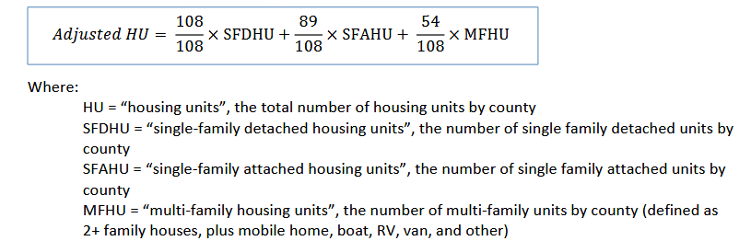
The following process was developed to estimate the total fuel use by county for fuel oil but has been applied to estimate the other six fuel types:
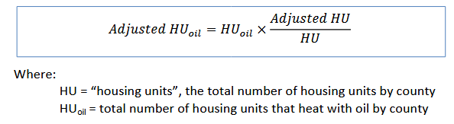
The residential consumption for each county weighted by structure type and county-specific heating degree day (HDD) was calculated as:
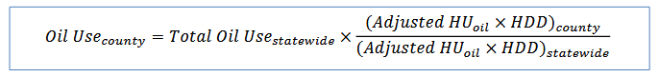
Once energy use was established for each fuel as described above, it was multiplied by the emission factors to estimate total emissions. Emission factors for CO₂, CH₄, and N₂O for each of the seven fuel types have been gathered from guidance based EPA’s Mandatory Reporting of Greenhouse Gases Program (GHGRP). Total emissions are calculated by gas and are rolled up into a total for each county.
Electricity consumption was applied to all households, rather than to just those using electricity as a heating fuel, to capture the total emissions, and falls under Scope 2. HDD weighting was not applied to electricity consumption, since the weighting should only affect the portion that heats with electricity, but that was not identified here. All other fuels considered here are Scope 1.
A modest number of households reported using coal or coke, yet statewide residential consumption was not available. Energy per housing unit values for fuel oil was used as a proxy to calculate coal or coke to correct for the unreported data.
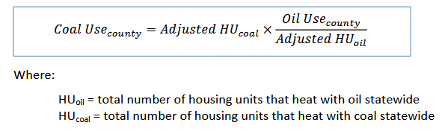
Commercial stationary combustion is estimated using a similar apportionment of the EIA’s state energy consumption in the commercial sector using SEDS, commercial fuel consumption Table CT5. The commercial apportionment from 2010 was used, as no updated information could be found, using the following methods.
First, the amount of commercial square footage by county was determined by multiplying the total number of commercial-sector jobs in each county (collected from the New York State Data Center and 2010 NYGHG Working Group and not changed in the 2021 Inventory Update) times the average square footage per worker per building type (collected from the Commercial Building Energy Consumption Survey and provided by the 2010 NYGHG Working Group). These were multiplied by the percentage housing units by fuel type as reported in the ACS served to estimate the amount of space heated by each fuel. Finally, the calculated consumption was weighted by HDD: the consumption of each fuel in each county equaled the commercial building area using that fuel times the regional HDD, divided by the sum of the products of commercial building area times HDD for all counties in the state. These estimates were overwritten with electricity and natural gas consumption data collected from the utilities wherever possible.
The primary data source for industrial stationary combustion is the EPA’s Greenhouse Gas Reporting Program (GHGRP) data for calendar year 2021. This dataset includes emission information from large facilities (defined as those that emit at least 25,000 MTCO₂e per year) in nine industry groups, including: power plants, landfills, metals manufacturing, mineral production, petroleum refineries, pulp and paper manufacturing, chemicals manufacturing, government and commercial facilities, and other industrial facilities. These groups cover 29 source categories of emissions. This data is available through a web tool or for download. This project used the most comprehensive dataset available, the full 2021 GHG Dataset.
Total statewide industrial fuel consumption for 2021 from EIA’s SEDS, Table CT6 and manufacturing employment in New York State and the Mid-Hudson Region counties were also used to supplement the GHGRP dataset. Manufacturing employment data came from the U.S. Census Bureau’s 2007 Economic Census, Employment by the North American Industry Classification System (NAICS) Code, codes 31–33. Not enough information could be found to update the data from the Economic Census.
Industrial stationary combustion emissions are estimated using a combination of reported direct emissions from the Mid-Hudson Region and a method to allocate statewide industrial fuel consumption to the Mid-Hudson Region counties.
First, data was pulled for known industrial emissions in the Mid-Hudson Region from EPA’s GHGRP dataset. The 2010 Inventory team used the following process to identify industrial facilities located in the Mid-Hudson Region. The process also checked, using the facility city, whether any facilities that did not have county designations were actually located in the Mid-Hudson Region. Finally, non-industrial facilities were removed from the list by NAICS code. Facilities that were removed from consideration were Utilities (with NAICS codes beginning with 22-), Lessors of Real Estate (531120), Solid Waste Landfills (562212), Solid Waste Combustors and Incinerators (562213), and Universities (611310). The result was a set of eight industrial facilities from the GHGRP dataset located in the Mid-Hudson Region.
Second, the industrial facilities from EPA’s GHGRP dataset were cross-checked (during the 2010 Inventory process and were not updated) with those in the Title V air permit data from the New York State Department of Environmental Conservation. To identify industrial facilities from the Title V dataset located in the Mid-Hudson Region, facilities were filtered by state and county. Non-industrial facilities were then removed from the list based on the listed Standard Industrial Classification (SIC) code, a related set of classification codes. Only facilities with SIC codes for Manufacturing (beginning with 20- to 39-), and Gas Production and Distribution (beginning with 492-) were kept. Facilities that were already included in the EPA’s GHGRP were removed. The result was a list of nine additional facilities located in the Mid-Hudson Region. Added to the eight GHGRP facilities, this resulted in a final list of 17 industrial facilities located in the Mid-Hudson Region.
The list of industrial facilities and their stationary combustion emissions established by the 2010 Inventory team was used by the 2021 Inventory Update team as a guide to update industrial emissions. The remaining industrial emissions (for example, from smaller industrial sources) are estimated using a process to allocate statewide industrial fuel consumption emissions to the Mid-Hudson Region counties based on industrial employment. Using 2021 industrial fuel consumption data (in trillion BTU) from EIA’s State Energy Data System, total New York State emissions, by fuel, were calculated using the default emission factors per MMBTU established by the NYGHG Protocol. The remaining emissions, statewide, were then allocated to the county level by the portion of statewide industrial manufacturing employment in that county (based on employment data by NAICS code from the 2007 Economic Census). Total emissions in each county represent the sum of reported emissions and the allocated emissions.
The following process was followed for each fuel type:
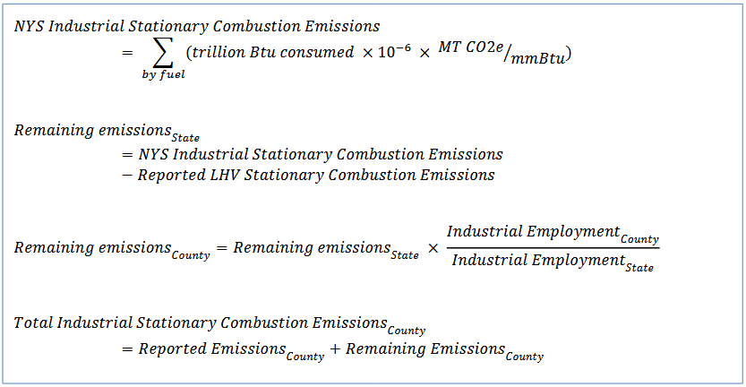
Currently, statewide industrial stationary combustion emissions are broken down into fuel types using the statewide GHGRP industrial stationary combustion emissions total, apportioned to fuel types based on EIA’s statewide fuel consumption data.

1.4 Energy Supply
Emissions that result from energy supply processes are included here. These include electricity transmission and distribution (T&D) losses, natural gas T&D losses, and the use of sulfur hexafluoride (SF₆) in the utility industry. The following methods are used to calculate emissions from each.
Data & Methods
To estimate losses due to electricity T&D, total electricity consumption (in MWh) is multiplied by a T&D loss factor to determine the quantity of electricity lost during T&D. The 2010 Inventory used the Eastern regional loss factor of 5.28% from eGRID. The 2021 Inventory Update uses the same eGRID loss factor. The total electricity lost is then multiplied by the electricity emission factors (either NYUP or NYCW) to estimate emissions from electricity T&D. For the four Westchester communities, Towns of Lewisboro, North Salem, Pound Ridge, and Somers, in NYSEG territory and the Towns of Bedford and Yorktown in both ConEd and NYSEG territory, the same emissions factors were used as described in the methods of Section 1.1 Electricity – Scope 2.
The following comes from the 2010 Inventory and has remained unchanged during the 2021 Inventory Update: Natural gas transmission and distribution losses from pipelines are sources of CH₄ emission. Utilities often report their average annual lost and unaccounted for (LAUF) natural gas to the New York Public Service Commission. Natural gas consumption data were gathered from Central Hudson Gas & Electric and Orange & Rockland Utilities and was estimated for the remaining utilities. Central Hudson Gas & Electric reports a three year (2005-2008) average LAUF of 1.07%. For utilities that do not report LAUF, the statewide average of 1.8% as documented by National Grid in Public Service Commission reporting will be used. The estimated natural gas consumption for each utility was multiplied by the LAUF and then converted from thousand cubic feet (Mcf) to MTCO₂e.
SF₆ is a greenhouse gas that is used as an electrical insulator in electricity T&D equipment. The SF₆ may escape from this equipment and emit into the atmosphere. To estimate these emissions, a national average implied emission factor is used. The emission factor is estimated by dividing 2021 total SF₆ emissions from electricity T&D from the U.S. Greenhouse Gas Inventory by total nationwide retail electricity sales from the EIA. The resultant factor of 0.0021 MTCO₂e /MWh was applied to total electricity consumption in the Mid-Hudson Region.

B.2. Mobile Energy Consumption

2.1 On-Road
On-road mobile transportation includes travel by motor vehicles on roads in the Mid-Hudson Region. The combustion of fuel in vehicles results in emissions of CO₂, CH₄ and N₂O. The amount of CO₂ emitted by vehicles depends on the amount of fuel consumed, whereas CH₄ and N₂O emissions vary based on control technologies used by vehicles. On-road vehicles include passenger cars, other 2-axle, and 4-axle vehicles, single-unit trucks, buses, combination trucks, and motorcycles.
Data & Methods
There are 3 data components needed to estimate mobile energy emissions:
- Types of vehicles on the road (“Vehicle Mix”)
- Distance traveled by on-road vehicles (“VMT,” vehicle miles traveled)
- Fuel consumption per vehicle type (“Fuel Economy”)
Vehicle Mix. Data on the on-road vehicle mix for each functional class of road (e.g., rural interstate, urban freeways and expressways) were obtained for each New York State Department of Transportation (NYSDOT) region from NYSDOT’s Environmental Science Bureau dataset. The breakdown of vehicle types for each functional class of road was translated to Highway Performance Monitoring System (HPMS) vehicle categories by the NYGHG Working Group in 2010. This was not changed in the 2021 Inventory Update.
Distance. Data on vehicle miles traveled (VMT) was obtained from NYSDOT modeled data for all counties. County-level VMT data was available by functional class of roadway for 2019 through a Freedom of Information Law (FOIL) Request to the NYSDOT.
Fuel Economy. State- or regional-level data on the fuel economy of the Mid-Hudson Region’s vehicle fleet were not available. As a proxy, national average fuel economy values by vehicle class were used based on the Federal Highway Administration’s Highway Statistics 2019 series.
Data Quality. Table 1 presents the data used to estimate emissions from on-road mobile energy consumption. As shown, 2009 data was unchanged for Vehicle Mix, and 2019 is the latest year available for VMT and Fuel Economy that was not impacted by the COVID-19 Pandemic.
Table 1 – On-road Energy Consumption Data Summary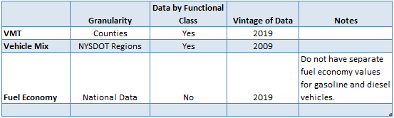
The general methodology for estimating CO2 emissions from mobile consumption is:
Fuel consumption in the Mid-Hudson Region was estimated by determining the distance traveled by different vehicle types and the amount of fuel consumed by each type of vehicle (fuel economy). First, data on total annual distance (VMT) traveled by vehicles within each county was allocated to vehicle types using the NSYDOT dataset on the breakdown of vehicles on NY roads (vehicle mix) by functional class of road. For each vehicle type and functional class, VMT data were multiplied by the average fuel economy of each vehicle type to determine total annual fuel consumption for each vehicle type. Total gasoline and diesel fuel consumption was then multiplied by the CO₂ emission factor for each fuel, which resulted in an estimate of CO₂ emissions for the region. In equation form:
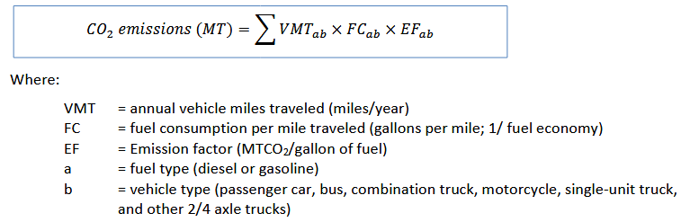
Based on guidance from the NYGHG Protocol, it was assumed that 10% of gasoline sold in New York is comprised of ethanol, so 10% of gasoline consumed was assumed to be ethanol. CO₂ emissions from ethanol were assumed to be zero, as biogenic CO₂ is not included in this inventory.
Methane and nitrous oxide make up less than 2% of on-road transportation emissions and require data on the types of vehicle control technologies in use in the region’s on-road vehicle fleet. For the 2010 Mid-Hudson Region GHG inventory, per the guidelines of the NYGHG Protocol, non-CO₂ emissions from vehicles were estimated by multiplying CO₂ emissions by the ratio of CH₄ and N₂O emissions from transportation per million tons (MT) of CO₂ emissions (MTCO₂e /MTCO₂). This ratio, obtained from the EPA’s Inventory of U.S. Greenhouse Gas Emissions and Sinks: 1990-2010, is 0.000994 MTCO₂e of CH₄ per MTCO₂ and 0.01367 MTCO₂e of N₂O per MTCO₂ of on-road transportation emissions. This ratio from the 2010 Inventory was used in the 2021 Inventory Update.

2.2 Air
Airplanes that fly in and out of airports in the Mid-Hudson Region are sources of emissions. This inventory uses the Scope 3 approach to estimate emissions from flight, which apportions national emissions based on the share of national commercial air mileage starting or ending at an airport in the region.
The six regional airports with recorded commercial flight data are Kline Kill Airport (airport code NY1) in Ulster County, Sky Acres Airport (NY5) in Dutchess County, Sullivan County International Airport (MSV) in Sullivan County, Stewart International Airport (SWF) in Orange County, Dutchess County Airport (POU) in Dutchess County, and Westchester County Airport (HPN) in Westchester County.
Data & Methods
There is not enough information available to update this sector. The methods used in the 2010 Inventory are as follows:
The flight dataset is from the U.S. Department of Transportation’s Bureau of Transportation Statistics. Data of interest includes the number of performed flights and the distance traveled in 2010. National flight emissions data (114,000,000 MTCO₂e) is from the U.S. Inventory for 2010.
The data was filtered to include only domestic flights from and to the six airports in the Mid-Hudson Region. Total miles traveled in 2010 were calculated for each route by multiplying the number of performed flights with the distance per trip. The total miles of flights from and to each of the six airports were calculated. Flight miles are halved in the emissions calculations because emissions from half the trip are attributed to the origin airport and half are attributed to the destination airport. This ensures that two regions following the same methodology would not double-count emissions. Regional flight emissions were calculated using the following:
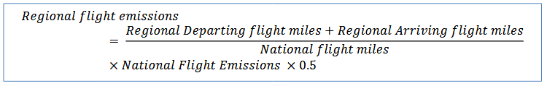

2.3 Marine
The marine transportation sector includes engines used for pleasure craft purposes and commercial marine vehicles on the Hudson River.
Data & Methods
There is not enough information available to update this sector. The methods used in the 2010 Inventory are as follows:
Non-commercial marine off-road vehicle use and emissions data for each of the seven counties in the Mid- Hudson Region in 2007 was obtained using EPA's NONROAD Emissions Model. The model input values were adjusted by the New York State Department of Environmental Conservation (NYS DEC). Among other emission types, the NONROAD model estimates carbon dioxide emissions. The emissions from all off-road vehicles within the pleasure craft classification in each county were summed and converted to MTCO₂e from short tons.
Commercial marine emissions for each county were calculated based on carbon monoxide (CO) emissions for the sector reported in the 2008 National Emissions Inventory. The National Emissions Inventory contains CO emissions, by county, for the “Mobile – Commercial Marine Vessels” sector. A ratio of CO₂ to CO emissions was used to estimate CO₂ emissions from commercial marine vessels. The ratio was based on CO₂ and CO emission factors for low-sulfur fuel oil no. 6. The CO₂/CO emission factor ratio (25,000 lb CO₂/10 3 gal over 5 lb CO/10 3
gal) was then multiplied by total CO emissions for each county to get CO₂ emissions for commercial marine vessels.

2.4 Rail
Emissions from railroad locomotives result from the use of diesel fuel.
Data & Methods
There is not enough information available to update this sector. The methods used in the 2010 Inventory are as follows:
Due to the limited amount of data available in this sector, the NYGHG Working Group elected to use data from the 2002 New York State Locomotive Survey as a proxy for 2010 emissions. The survey collected information on 2002 locomotive fuel use for four categories of locomotives: Class I, Class II/III, commuter/passenger, and switchyard. Class I railroads are large, long-distance line haul railroads and Class II and III railroads consist primarily of regional and local line haul and switching railroads. Yard locomotives move railcars within a particular railway yard.
The survey reported county-level fuel consumption for Class I and system-wide fuel consumption estimates for Class II/III locomotives. The survey also reported county-level fuel consumption estimates from passenger/commuter lines that operate diesel locomotive cars. The Class I rail companies in New York State operate switchyards and the fuel consumption from switchyards in the Mid-Hudson Region could not be separated out from line haul fuel consumption.
The county-level Class I and commuter/passenger fuel consumption estimates were multiplied by the diesel fuel CO₂ emission factor to calculate CO₂ emissions. The fuel consumption estimates were converted by the diesel density factor and multiplied by the emission factors and global warming potentials to calculate CH₄ and N₂O emissions. The inventory does not report emission from the Class II/III rail type because the fuel consumption estimates are not reported by county.

2.5 Off-Road
Emissions from off-road vehicles include engines used for agricultural, construction, lawn and garden, and off-road recreation purposes.
Data & Methods
There is not enough information available to update this sector. The methods used in the 2010 Inventory are as follows:
Off-road vehicle use and emissions data for each of the seven counties in the Mid-Hudson Region in 2007 was obtained using EPA's NONROAD Emissions Model. The model input values were adjusted by NYS DEC. Among other emission types, the NONROAD model estimates carbon dioxide emissions. The emissions from all off road vehicles, excluding those in the pleasure craft classification, in each county were summed, and converted to MTCO₂e from short tons. To avoid double counting, the emission of vehicles in the pleasure craft classification is accounted in the marine emission source and is not included in the off-road emission source.

B.3. Waste Management
The waste management sector encompasses solid waste and wastewater. The organic material in solid waste and wastewater degrades during the decomposition and treatment processes and emits greenhouse gases.

3.1 Solid Waste
The decomposition of organic matter in solid waste produces methane. For this inventory, both Scope 1 and Scope 3 emissions for solid waste were calculated. Scope 1 represents emissions from landfills located within the region, regardless of where the waste originated. Scope 3 represents emissions from waste generated by the region, regardless of where the wasted is ultimately transported. To avoid double-counting, only Scope 3 emissions are included in the total and Scope 1 emissions from solid waste are reported here for informational purposes.
Scope 1
Scope 1 solid waste accounts for emissions from landfills located within Mid-Hudson Region counties. According to the NYS DEC, there are no active municipal solid waste landfills in the Mid-Hudson Region as of December 30, 2021. However, closed municipal solid waste landfills may still be sources of emissions because waste emits methane for several decades as it decays. Closed large municipal solid waste landfill facilities in the region include Orange County Landfill and Croton Landfill. These two landfills were not included in the 2010 Inventory due to data not being reported to the EPA’s GHGRP during the time the inventory was being completed.
In addition to the Orange County and Croton Landfills, there are two other landfills that are included within the EPA’s GHGRP: Al Turi Landfill and Sullivan County Landfill. Al Turi Landfill was reporting to the EPA from 2010-2016 but has “discontinued reporting without a valid reason as of August 12,2022.” Sullivan County Landfill discontinued reporting for a valid reason in 2016. Landfill facilities are eligible to stop reporting when emissions are less than 15,000 MTCO₂e for three consecutive years, or less than 25,000 MTCO₂e for five consecutive years.
Scope 1 does not include emissions from waste combustion facilities to avoid double-counting. Those facilities, which are also used to generate electricity, are included under electricity generation. Much of the electricity generated from these facilities is also accounted for in electricity consumption.
Data & Methods
Data on emissions from landfills came from EPA’s GHGRP data for calendar year 2021. This dataset includes emission information from large facilities (defined as those that emit >25,000 MTCO₂e per year) in nine industry groups, including landfills. This data is available through a web tool for download. Methane emissions from landfill processes were reported as solid waste Scope 1 emissions.
Scope 3
Solid waste Scope 3 accounts for emissions from waste generated within the Mid-Hudson Region counties, regardless of where the waste is sent.
Data & Methods
Solid waste data from landfill facilities were compiled from NYS DEC 2021 Annual Landfill Facility Reports. The solid waste data was filtered to include landfill facilities that service, or receive waste from, the counties in the Mid-Hudson Region. Landfill gas (LFG) collection acreage, total landfill acreage, and percent alternative daily cover (ADC) data were gathered from NYS DEC 2021 Annual Landfill Facility Reports. Solid waste data from waste combustion facilities that service the counties in the Mid-Hudson Region were gathered from NYS DEC 2021 Annual Municipal Waste Combustion Facility Reports.
The Annual Landfill Facility Reports provide solid waste data from all NYS landfills that service the counties in the Mid-Hudson Region, except for Putnam County. Data was available from the Putnam County Department of Solid Waste Management on the number of tons of solid waste Putnam County sent to Wheelabrator Westchester. The tons of solid waste generated in Putnam County was estimated using the following equation: population multiplied by MSW disposal per capita (lbs/day) multiplied by365/2000. The tons of incinerated waste from Putnam County was then subtracted from the estimated MSW generated annually. This was done because, of the total waste generated in Putnam County, the remaining 4.6% of waste that is not incinerated is sent to an out of state landfill – this landfill was named “Out of State Landfill.”
The weighted percentage of landfill area with LFG capture and weighted ADC were calculated for each county based on the landfills that accept municipal solid waste (MSW) from each county. For each unique landfill facility that services the Mid-Hudson Region, the percentage of land in which gas is collected was calculated by dividing the gas collection acreage with the total landfill acreage. The amount of MSW and construction and demolition waste (C&D) generated by each county that was sent to landfills was calculated by summing the amount of waste from the “service area(s)” of interest, which are the counties in the Mid-Hudson Region. Then, the percentage of land with LFG capture for landfill facilities that collect MSW from each county were weighted by the amount of MSW received from that county. The portion of land with LFG captured for all counties ranged from 97% to 100%. The ADC percent for landfill facilities that collect MSW from each county were also weighted by the amount of MSW received from that county. For Putnam County’s “Out of State Landfill” the %LFG Capture and ADC % were calculated by averaging the percentages from the other landfills that service the region. The inventory assumes no LFG capture and ADC for C&D waste.
Because the data from the Landfill Facility Reports does not include waste handled at transfer stations or waste sent out of state, the inventory estimated total MSW generated by using MSW daily disposal per capita for each county. This also ensured that the assumptions used here are consistent with data used by the Mid-Hudson Regional Sustainability Plan. The New York State Draft Solid Waste Management Plan provided data on MSW disposal per capita which was compiled from various sources summarized in Table 2. The daily disposal per capita was multiplied by the counties’ population, converted from pounds to tons, and converted from daily waste generation to annual. Using the data from the NYS DEC Annual Reports, the percentages of generated MSW and C&D that were landfilled versus combusted in each county were calculated. The amount of waste generated was multiplied by the counties’ fraction of waste that is sent to landfills to determine the amount of MSW landfilled. The amount of ADC was also calculated by multiplying the MSW landfilled with the weighted ADC percent for each county. The inventory sums up the amount of C&D generated using the data from the DEC Annual Reports because those are the only sources with C&D data.
Table 2 – Waste Data from NYS Solid Waste Management Plan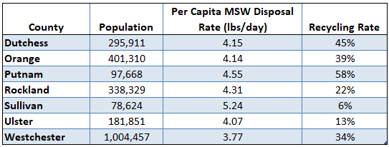
Note: Recycling Rate includes MSW recycled/composted and C&D materials but does not include combusted materials.
The California Air Resources Board (CARB) Landfill Emissions Tool Version 1.3 from 2011 was used to calculate Scope 3 emissions. The 2021 version of the tool that is publicly available via CARB’s website could not be edited; therefore, Version 1.3 was used to input NYS-specific waste in place fractions. The tool implements the mathematically exact first-order decay (FOD) model of the 2006 IPCC guidelines. The methodology of the FOD model is available in the Local Government Operations Protocol.
The tool is used to calculate emissions that the waste generated in 2021 will emit over its lifetime in a landfill. First, the number of years for which waste generated during the inventory year will be releasing methane was calculated. The half-life of landfilled waste was calculated through the following equation: k = ln(2)/half-life in years. K is determined based on the amount of annual rainfall in the county, and an average rainfall of greater than 40 inches per year was assumed for all counties in the Mid-Hudson Region. Given the rainfall assumption, k= 0.057. The half-life was multiplied by four half-lives to determine T, the number of years for which waste deposited during the inventory year will be releasing methane.
NYS DEC completed a revised solid waste plan, New York State Draft Solid Waste Management Plan, which builds upon the State’s 2010 Beyond Waste Plan. The plan includes data on estimated composition of waste discarded in 2023, and is categorized by rural, suburban, and urban settings. NY State-specific solid waste discard composition data was used to find the fractions of waste types which contain anaerobically degradable carbon (ANDOC). For the municipal solid waste (MSW) component, the inventory assumes the waste composition from suburban settings for Dutchess, Orange, Putnam, Rockland, and Westchester Counties and from rural settings for Sullivan and Ulster Counties. For the purposes of the solid waste analysis, NYS DEC defines rural as communities in the state with a population density of less than 325 people per square mile and suburban areas as communities with a population density between 325 and 5,000 people per square mile. The inventory assumes the waste composition for the construction and demolition (C&D) waste emission analysis is 100% C&D.
The county and NY State-specific information was used to replace the California-specific default data in the tool. In the “Landfill Model Inputs tab,” the state/country input was set to “US-Other”, and the k value was set to 0.057. The amount of solid waste generated in the inventory year was entered into the tool’s “Landfill Model Inputs tab” T years prior (1972) to the inventory year. Because the tool Version 1.3 reports until 2020, the amount of solid waste generated was inputted one year prior to T years (1971) to account for the total lifetime the waste generated in 2021 will emit. The NY State-specific waste in place fractions were entered into the “Landfill Specific ANDOC Values” tab of the tool. The new % ANDOC value was entered into the “Landfill Model Inputs” tab to replace the default numbers. The amount of ADC was entered into the tool for MSW estimates and assumes the daily cover is composed of green waste and compost. The default % ANDOC value for daily cover that was calculated by the tool was used. The inventory assumes no ADC for C&D waste.
The sum of methane emission results over T years represents the total amount of methane expected to be released by inventory year waste generated and deposited in a landfill without a LFG collection system. The methane emissions for MSW waste were then adjusted for a LFG collection system. The EPA default LFG collection efficiency of 75% was assumed because the weighted percent of land with LFG collection per county, ranging from 97 to 100%, indicates comprehensive LFG systems. The sum of methane emissions was multiplied by 100% minus the default LFG collection efficiency to determine methane emissions from MSW generated and deposited in a landfill without a LFG collection system. The inventory assumes no LFG collection for C&D waste. Carbon dioxide emission outputs from the solid waste tool are considered biogenic and are not included in the inventory emissions.

3.2 Wastewater
When organic waste material in wastewater degrades during the wastewater treatment processes, it emits both methane and nitrous oxide. Methane is emitted during anaerobic digestion of wastewater, and nitrous oxide is emitted when nitrogen components in wastewater degrade. The amount of methane and nitrous oxide emitted from wastewater depends on the type of wastewater treatment processes used, such as septic systems, centralized wastewater treatment plants (WWTPs), and anaerobic digesters.
Data & Methods
Wastewater treatment emissions are calculated based on the population served by wastewater treatment processes. The population served by WTTPs in the region was gathered from individual county or municipality websites. Some municipalities track the number of connections to the sewer system, and not the total population served. Where only the number of connections were available, that number was multiplied by the average household size (2.8) to get total population. Where county or municipal data was not available, population totals were taken from NYS Open Source Data: Descriptive Data of Municipal Wastewater Treatment Plants. Although the exact timeframe of this data was not available, it was used because the dataset description is “current through the most recent survey.”
In the 2010 Inventory, all communities were attributed wastewater treatment emissions, even those that are not served by a WWTP, and no septic emissions were calculated. The 2021 Inventory Update team chose to zero the wastewater treatment emissions for communities where the entire population is on a private septic system. If a community is interested in calculating septic system emissions, HVRC made a wastewater emissions calculator that calculates septic emissions and is available on its website. The wastewater emissions calculator uses the following equation to calculate the emissions from all septic systems in a community.
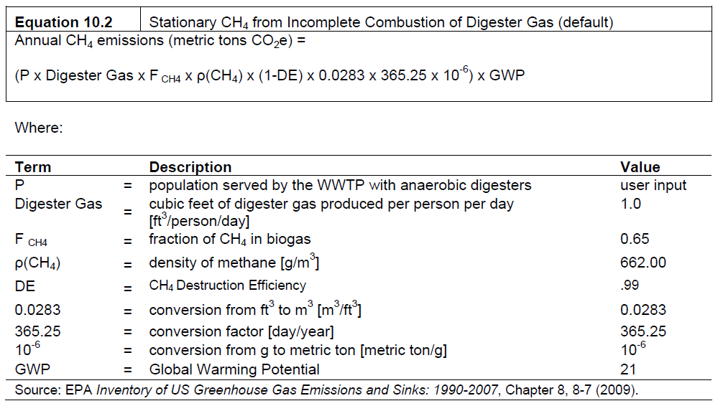
There are four towns that do not have WWTPs but have a village within the town that uses a WWTP covering the entire population of the village. The populations of these towns were updated to only include the village population in the wastewater treatment emissions allocation. This was done because village emissions are included in town emissions roll-ups. Therefore, the total wastewater treatment emissions will only be that of the village, and if the town chooses to subtract village emissions from its total, its wastewater treatment emissions will be zero. This was done for the Towns of Hamptonburgh, Philipstown, Washington, and Wawarsing.
Wastewater treatment emissions were calculated using EPA’s State Inventory Tool (SIT) modified for use in individual counties. Methane emissions from municipal wastewater treatment were calculated by multiplying the population served by municipal WWTPs, found either directly from the county/municipality or taken from NYS Data, by the annual per-capita 5-day biological oxygen demand (BOD₅) rate times the emission factor of CH₄ emitted per quantity of BOD₅. Default values for New York State in the SIT were used. The percentage of the population not on septic was updated to 100% to account for the population being input into the SIT equaling the number of people in each county served by wastewater treatment.
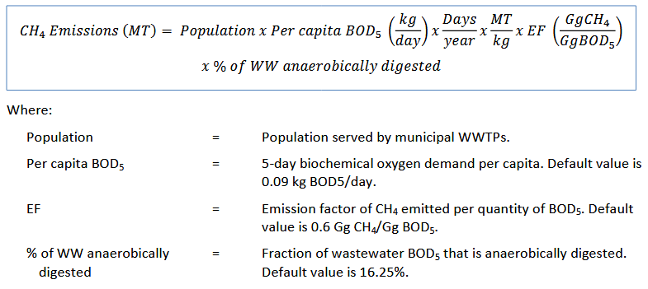
Nitrous oxide emissions from municipal wastewater treatment were calculated by multiplying the population served by the percent of the population using centralized wastewater treatment (not septic systems), times the amount of direct N₂O emissions from wastewater treatment per person per year.
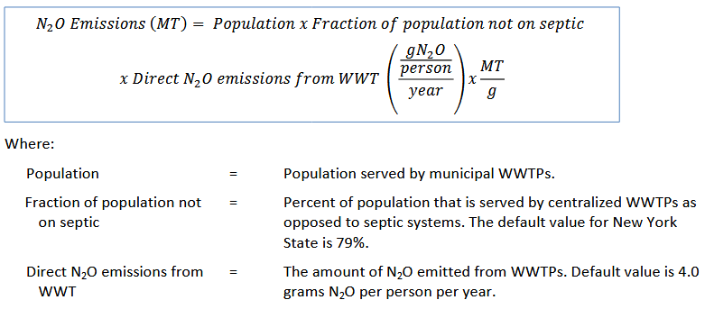
Nitrous oxide emissions from wastewater biosolids were calculated using the following equation:
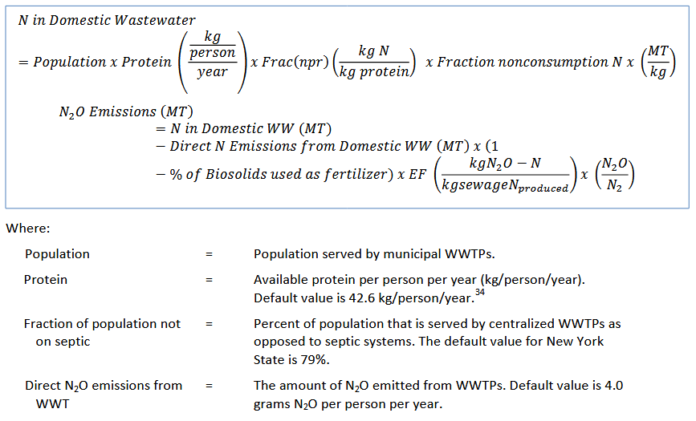

B.4. Industrial Processes
Industrial process emissions are those produced as by-products of non-energy-related industrial activities. In the Mid-Hudson Region, the primary industrial actor is Revere Smelting and Refining Corporation, which is a lead manufacturer.
Data & Methods
Industrial process emissions for the Mid-Hudson Region were estimated for two emission sources to cover the industrial process emissions in the Mid-Hudson Region. These sources are CO₂, CH₄, and N₂O from general industrial activity as reported by large facilities and hydrofluorocarbon (HFC) emissions from ozone depleting substances (ODS) substitutes.
Data on industrial activity from large facilities came from EPA’s GHGRP data for calendar year 2021. This dataset includes emission information from large facilities (defined as those that emit > 25,000 MTCO₂e per year) in nine industry groups, including: power plants, landfills, metals manufacturing, mineral production, petroleum refineries, pulp and paper manufacturing, chemicals manufacturing, government and commercial facilities, and other industrial facilities. These groups cover 29 source categories of emissions. This data is available through a web tool or for download. This update used the most comprehensive dataset available, which is the full 2021 GHG Dataset.
To calculate emissions from ODS substitutes, the Mid-Hudson Region developed an implied emission factor based on total national ODS substitute emissions and population. National ODS substitute emissions came from EPA’s national GHG inventory. Total 2020 U.S. population was collected from the U.S. Census Bureau.
Industrial Facility Emissions - The primary data source is EPA’s GHGRP data for calendar year 2021. To identify facilities located in the Mid-Hudson Region, the full dataset of facilities was filtered by state and county. The process also checked, using the facility city, whether any facilities that did not have county designations were located in the Mid-Hudson Region. The result was one facility located in the Mid-Hudson Region Revere Smelting & Refining Corp. The inventory only includes emissions from lead production under Industrial Processes. Stationary combustion, electricity production, and landfill emissions are included elsewhere in the inventory.
ODS Substitute Emissions - To supplement the GHGRP data, emissions were also calculated for ODS substitutes, a key industrial process emissions source category not covered in the EPA dataset. The Mid-Hudson Region used an implied per capita emissions factor based on the national greenhouse gas inventory for 2021. Equipment that use ODS Substitutes are widely distributed throughout all households and businesses. Total 2020 ODS substitution emissions (166.1 Tg CO₂e) were divided by total 2020 U.S. population (331,449,281) to derive an implied per capita emission factor. This implied emissions factor was multiplied by the population of each of the municipalities in the Mid-Hudson Region to estimate emissions from this industrial process source category.

B.5. Agriculture
The agriculture sector of the Mid-Hudson Regional inventory includes non-carbon dioxide emissions from enteric fermentation in domestic livestock, livestock manure management, and agricultural soil management (including fertilizer application). Carbon dioxide emissions are not included as they are assumed to be biogenic and don’t represent an anthropogenic emission source.
According to the Mid-Hudson Region’s Strategic Economic Development Plan, the percentage of land that is farmed in each county is 20% in Dutchess, 16% in Orange, 4% in Putnam, 3% in Westchester, and 11% in Ulster. The percentage of farmland in Rockland is negligible, and the figures for Sullivan County are not available. These percentages were taken from the 2010 Inventory and not changed. The primary agricultural industry in the region is dairy production, along with other livestock production. The primary crops in the region are corn (for grain and silage), forage, oats, and soybean.
Data & Methods
There is not enough information available to update this sector. The old methane and nitrous oxide emissions factors were used; therefore, the results remain unchanged from 2010 agriculture emissions totals. The methods used in the 2010 Inventory are as follows:
Data on 2010 livestock populations and crop productions were available for New York State on the county-level from USDA’s National Agricultural Statistics Service (NASS). Livestock populations for 2010 included beef cows, milk cows, and all cattle (including calves). Calf populations were calculated by assuming that calves account for 17.4% of the total non-dairy cattle/cow population. Data for crop production in the Mid-Hudson Region counties covered corn for grain, hay alfalfa, other dry hay, oats, soybeans, and winter wheat.
Data from EPA’s Regional GHG Inventory Guidance on livestock population percentage breakdowns in New York State was also used to allocate dairy cattle and beef cattle populations into sub-categories. The subcategories for dairy cattle are dairy cows and dairy replacement heifers. The subcategories for beef cattle are beef cows, beef replacement heifers, heifer stockers, steer stockers, feedlot heifers, feedlot steer, and bulls.
Fertilizer sales data came from the New York State Department of Agriculture and Markets dataset of total fertilizer and nutrients by county for calendar year 2010. For each county, the dataset included total fertilizer sales, broken into single, multi-nutrient, and other; Total N, P205, and K20 in multiple-nutrient fertilizer, and total N, P205, and K20 in all fertilizer.
County-level emissions for agriculture were calculated using EPA’s State Inventory Tool (SIT), using default emission factors for New York State. To calculate emissions from enteric fermentation and manure management, the tool requires population information for each livestock subcategory. Total county milk cow population and beef cow population from NASS were multiplied by the percentage breakdowns from EPA’s Regional GHG Inventory Guidance to derive subcategory populations. The tool then multiplies the number of animals by a per-head enteric CH₄ emission factor to estimate total enteric fermentation emissions for each county. The tool multiplies the subcategory populations by New York defaults for Typical Animal Mass (TAM), volatile solids (VS), and methane conversion factors for different manure management systems to estimate CH₄ emissions from manure management and by TAM, K-Nitrogen factors, and nitrogen emission factors for different manure management systems to estimate N₂O emissions from manure management.
To calculate emissions from management of agricultural soils, the SIT follows three steps. The tool first calculates emissions from plant residues and allows input of crop production data for 21 crop types. Five of these crop types are grown in the Mid-Hudson Region: Alfalfa (pulled from NASS as “Hay Alfalfa (Dry)”), corn for grain, wheat, oats, and soybeans. The tool multiplies these production amounts by a series of factors, including residue dry matter fraction, fraction residue applied, and nitrogen content of residue to calculate the amount of nitrogen returned to soils and the amount of nitrogen fixed by crops.
The second step of calculating emissions from agricultural soil management estimates emissions from plant fertilizer application. The tool uses the total amounts of fertilizer nitrogen by type (synthetic fertilizers, dried blood, compost, dried manure, activated sewage sludge, other sewage sludge, tankage, or other organic amendments) to estimate direct and indirect N₂O emissions from fertilizer applications. For each county, the total N in all fertilizer types from the New York State dataset was entered into the tool under “Synthetic Fertilizer” to estimate fertilizer emissions.
Finally, the SIT calculates agricultural soil emissions from animals and runoff. This step uses the livestock population data entered under enteric fermentation and manure management and New York state default distributions of livestock management systems (e.g. managed systems, pasture, and daily spread) along with built-in emission factors to estimate N₂O emissions.

B.6. Land Use, Land-Use Change and Forestry
Land Use, Land-Use Change and Forestry (LULUCF) measures changes to forest carbon stocks. This measurement reflects the impact of changes in land use on the capacity of forests in the Mid-Hudson Region to store (or “sequester”) carbon in their trees, forest litter, and soils. Forest carbon sequestration is the process by which atmospheric carbon dioxide is taken up by trees through photosynthesis and stored as carbon in biomass (trunks, branches, foliage, and roots) and soils. This source is considered “optional” under the guidance of the NYGHG Working Group. However, it is included here due to the importance of forest resources to the region.
Data & Methods
Two datasets were used to calculate net emissions from LULUCF: (1) the acres of forested land by county in 2010 and 2020 and (2) the carbon sequestration rates for forests in the region.
In 2010 the acres of forested land were retrieved from the U.S. Forest Service’s Forest Inventory and Analysis database via the Forest Inventory Data Online (FIDO) website. The FIDO website was not functional at the time of completing this inventory update. Therefore, data was gathered by Dr. Charles Canham, Senior Scientist, Emeritus, Cary Institute of Ecosystem Studies, who used data from U.S. Forest Service’s Forest Inventory and Analysis (FIA) Program. Data were originally pulled by county by forest-type group for 1993, 2005 and 2010. The three data samples revealed some inconsistencies in the identification of specific forest-type groups. However, the differences between the total forested area per county demonstrated reasonable changes in acreage. Therefore, to minimize the influence of data sample errors, the calculations were based on the total forested area for each county, and not forest-type groups; the same was done for the 2021 Inventory Update. In the 2010 Inventory, 2005 and 2010 sample years were selected, therefore the 2021 Inventory Update team chose to compare 2010 to 2020.
The second set of data, carbon sequestration rate in the Mid-Hudson region, was calculated by Dr. Canham. Using FIA data to find average total forestland carbon stocks, a slope trend of annual increase in metric tons of carbon/hectare was calculated. This value (0.9611) was multiplied by the metric tons of carbon to metric tons of carbon dioxide conversion (44/12) to get an average carbon sequestration rate of 3.52 MTCO₂e.
Calculations estimated the average annual rate of carbon sequestration in the counties. The methodology included a four step calculation:
- Subtracted the 2010 acres of forest per county from the 2020 acres of forest per county.
- Divided the change by 10 (years) to get the annual rate of change in acres.
- Converted acres of forest to hectares.
- Multiplied the annual rate of change in hectares by the above carbon sequestration rate.

Appendix C. Municipal-Level Allocation

C.1 Introduction
In addition to the regional GHG inventory presented above, this analysis included a municipal-level allocation of regional emissions. The 2010 Inventory team allocated the region’s emissions to individual towns, cities, and villages based on the available data; the same was done for this update. This effort is intended to provide municipalities with baseline information about their community-level GHG emissions. Because it was not feasible to develop ground up GHG inventories for each of the region’s 205 cities, towns, and villages, the allocation process was driven by readily available demographic and geographic data. A detailed, ground-up inventory would likely provide more reliable results for any one community, but these estimates serve as a useful resource for those communities unable to complete their own GHG inventories. The challenges and limitations of this process are described below, followed by a description of the methods for each sector.

C.2 Challenges
Data Limitations and Unallocated Portion
It was not practical to fully allocate all emissions from each sector in the region. The GHG Working Group determined in 2010 to allocate those sources where available local-level activity data could be used to reasonably approximate the spatial distribution of emissions. In cases where no such data were available, regional emissions were not allocated to the local level. Specifically, emissions from rail, marine, aviation, and LULUCF have not been allocated to the municipal level for this inventory. It would be possible to allocate sources such as aviation based on a survey of passenger air travel habits by municipality, but conducting such a survey was beyond the scope of this analysis.
Furthermore, only a subset of industrial emissions and a subset of off-road emission were allocated, as discussed below. The percentage not allocated by sector is shown below in Table 3. Residential and Commercial Stationary Energy Consumption are not 100% allocated to the municipal level due to different emissions factors for electricity consumption in Westchester County. Six Westchester municipalities were allocated to the NYUP emissions factor instead of the NYCW emissions factor, but the County itself is using the NYCW emissions factor.
Additionally, Scope 1 emissions from electricity generation—which was calculated for informational purposes but not included in the regional total—were not included in the municipal allocation.
Table 3 – Percentage of Emissions Not Allocated, by Sector
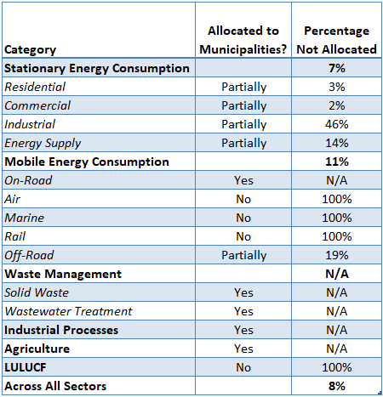
Including Villages
Although village populations are also included within town population estimates, the inventory has been allocated to the village level, where possible. Because there is overlap between towns and villages, these allocations should not be viewed additively. For example, three villages could be part of one town; the emissions allocated to each village should not be viewed as mutually exclusive from the town but are also included in the town’s emissions estimates. However, there is value in understanding emissions from each village for facilitating planning activities to target reducing emissions from specific sectors and locales.

C.3 Methods by Sector
Stationary Energy Combustion
Electricity – Scope 1
Electricity generation emissions are not allocated to the municipal level, as they are not counted in county emission totals.
Electricity – Scope 2
Electricity consumption emissions are calculated at the municipal level initially and then added up to the county level. See Appendix B Section 1.2 for methodology details.
Fuels – Scope 2
Residential fuel consumption at the municipal level is calculated using the same methodology described in Appendix B Section 1.3, based on Census data for housing units, heating fuel use, and statewide residential fuel consumption. Utility data for each municipality, if available, override these estimates.
Commercial fuel consumption at the municipal level is calculated using the same methodology described in Appendix B Section 1.3, based on Census data for housing units, heating fuel use, and statewide commercial fuel consumption. Utility data for each municipality, if available, override these estimates.
Industrial fuel consumption at the municipal level is based on reported data from three sources: EPA’s Greenhouse Gas Reporting Program (GHGRP) industrial facilities, the New York State Department of Environmental Conservation (NYS DEC) Title V facilities database, and utility data. Industrial stationary combustion emissions from any facilities within a municipality are assigned to that municipality. For natural gas combustion, utility data overrides GHGRP/Title V facilities data if both are available. The estimated data used to account for consumption not covered by these three sources was not allocated due to the lack of sufficient local level data.
Energy Supply
Electricity and natural gas transmission and distribution emissions at the municipal level are calculated using the same methodology as at the county level. Electricity and natural gas consumption for each municipality is multiplied by a transmission and distribution loss factor and converted to emissions. SF₆ emissions are also calculated in the same manner for municipalities as for counties, using municipal-level electricity consumption multiplied by the SF₆ loss rate in MTCO₂e per MWh. See Appendix B Section 1.4 for details.
Transportation
For the transportation sector, on-road motor vehicle activity, as well as off-road terrestrial vehicle activity, has been allocated to the town level. However, due to lack of data and solid methodological options, rail, marine, and air subsectors have not been similarly allocated. See the discussion on data limitations and unallocated portions for more information.
On-Road Transportation
On-road emissions in Mid-Hudson Region were allocated to municipalities based on the number of occupied housing units (households) in cities, towns, and villages adjusted based on the journey-to-work mode preference. Household data were obtained from the American Communities Survey 5-year estimates on selected housing characteristics, as were journey-to-work percentages. First, the weighted proportion of commuters driving alone was calculated for each municipality and each county:
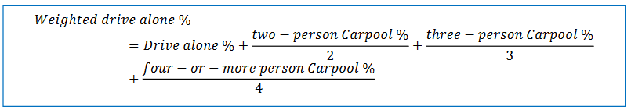
Next, the weighted proportion of commuters driving alone was normalized by dividing by the county-wide average for each county to provide a “journey-to-work factor” (JTWF, in the equation below). Municipal on-road emissions were estimated by multiplying the county-level emission estimates by a weighting based on the number of households within each municipality and the prevalence of vehicle use for commuting relative to the rest of the county:
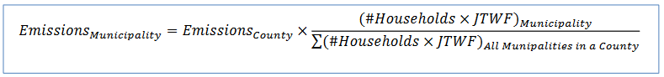
Off-Road Transportation
The methodologies for allocating off-road emissions to the municipal level varied by equipment type. Emissions from recreational and logging equipment were allocated based on the inverse of population density, assuming that these types of equipment are more common in areas with more space available per person. The population density was normalized to the county average by dividing the inverse of the log of each municipality’s population density by the inverse of the log of the county’s population density. The normalized population density was multiplied by the municipality’s 2020 population. This was divided by the sum of the products of the population and normalized density of towns and cities to find the proportion of population density with respect to the county. The proportion was multiplied with the county’s emissions from recreational and logging equipment. The net result of this weighting is that usage was weighted by population but given a higher weighting in places with low population density, and a lower weighting in places with high population density.
Emissions from construction and mining equipment were allocated based on population. The municipalities’ population proportions within their respective county were multiplied by the county’s emissions from construction and mining equipment.
Residential and commercial lawn and garden equipment considered the number of single family housing units. The number of total single family detached and attached housing units within the municipality was divided by the total within their respective county. The housing unit proportion was multiplied with the county’s emission from residential and commercial lawn and garden equipment. This calculation was based on the activity factors used in the EPA model used to generate these estimates.
Emissions from commercial equipment were allocated based on allocations from the commercial fuel source. The commercial fuel emission from each municipality was divided by the total emissions from their respective county. The commercial fuel proportion was multiplied with the county’s emission from commercial equipment.
Emissions from industrial, airport, agricultural, and railroad equipment, which represent 19% of off-road emissions in the region, were not allocated at the municipal level due to lack of available data or methodology.
Waste Management
Solid Waste
Scope 1 solid waste emissions were allocated to municipalities based on location of the landfill facilities. Scope 1 emissions are not included in the allocation totals for waste, however, to avoid double-counting. Scope 3 emissions were allocated to municipalities based on Census-derived populations. The towns, cities, and villages’ population proportions within each of their respective counties were multiplied by the county’s overall Scope 3 per-capita emissions.
Wastewater
Wastewater emissions were calculated using EPA’s State Inventory Tool. Methane emissions from municipal wastewater treatment were calculated by multiplying the population served by municipal WWTPs, from the Census 2020 population data for each municipality, by the annual per-capita 5-day biological oxygen demand (BOD₅) rate times the emission factor of CH₄ emitted per quantity of BOD₅. Default values for New York State in the SIT were used. See Appendix B Section 3.2 for more information.
Industrial Processes
Industrial process emissions at the municipal level are calculated using the same methodology as calculating emissions at the county level (see Section 4). Industrial process emissions from a single facility in the region, the Revere Smelting and Refining Corp. facility located in Middletown, New York, are assigned to that city. Emissions from ODS substitution are assigned to municipalities based on population and the implied per capita ODS emission factor.
Agriculture
Emissions from the agricultural sector are apportioned to the municipal level using GIS-based land use data from the USDA’s National Agricultural Statistics Service. The dataset provides land area by crop type throughout the United States. Using this dataset, the area of each land use type within the Mid-Hudson Region municipalities was determined.
To apportion emissions, first, the relevant land use types were determined. For Ag Soils, the land uses for the crop types grown in the Mid-Hudson Region and calculated in the State Inventory Tool were used. These crop types are Alfalfa, Corn, Winter Wheat, Oats, Soybeans, and Dry Beans. The sum of the land area for each of these crops for each municipality was considered its “Ag Soils Land Area.”
For livestock emissions (Manure Management and Enteric Fermentation in the SIT), land area categorized as “Pasture/Grass” was used to determine the “Livestock Land Area.”
Finally, total agricultural emissions (Ag Soils Emissions plus Livestock emissions) for each municipality were determined using the equations below:
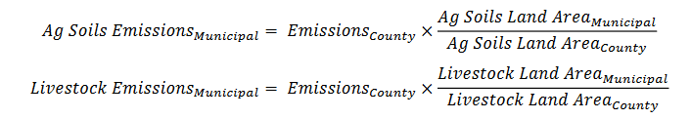

The original report can be found at: https://climatesmart.ny.gov/support/regional-greenhouse-gas-inventories-in-nys/
https://climatesmart.ny.gov/fileadmin/csc/documents/GHG_Inventories/ghgguide.pdf
New York State Data Center, Estimates of the Resident Population: New York State Governmental Units, 2000 to 2009 – Revised September 2010.
Ibid.
U.S. EPA, Inventory of U.S. Greenhouse Gas Emissions and Sinks: 1990-2021, April 2023.
IPCC, 2006 IPPC Guidelines for National Greenhouse Gas Inventories.
Different greenhouse gases have different capacities to trap heat in the atmosphere. To compare and sum the impacts of different gases, the United Nations’ Intergovernmental Panel on Climate Change (IPCC) developed the Global Warming Potential (GWP) concept, in which the GWP of each greenhouse gas is compared to that of CO₂, whose GWP is defined as 1. The GWP of methane (CH₄) is 21, and nitrous oxide (N₂O) is 310. GWPs for some gases are much higher—the GWP for SF₆, for example is 23,900. For more information, see US EPA, Inventory of U.S. Greenhouse Gas Emissions and Sinks: 1990–2021, April 2023.
US EPA, Inventory of U.S. Greenhouse Gas Emissions and Sinks: 1990–2021, April 2023.
U.S. Energy Information Administration, 2022. Form EIA-923 detailed data merged with 860 form data.
U.S. Energy Information Administration, 2022. Interactive GIS Data Viewer.
Utility Energy Registry. https://utilityregistry.org/app/#/
NYSERDA. Community Choice Aggregation.
Sustainable Westchester. Westchester Power 2022 Annual Report.
Joule Community Power. 2022 Annual Report.
EPA, 2021. eGRID.
U.S. Census Bureau, 2020. Table H1 – Housing Units.
U.S. Census Bureau, 2020. Table DP04 – Selected Housing Characteristics.
U.S. Energy Information Administration, 2021. Residential Fuel Consumption, Table CT4. SEDS New York.
U.S. Energy Information Administration, 2021. Commercial Fuel Consumption, Table CT5. SEDS New York.
U.S. EPA, Greenhouse Gas Reporting Program FLIGHT Tool.
U.S. Energy Information Administration, 2021. Industrial Fuel Consumption, Table CT6. SEDS New York.
U.S. Energy Information Administration, 2021. SEDS New York Industrial Fuel Consumption Table CT6. The fuel type “Other Petroleum Products” was adjusted to remove Asphalt and Road Oil, which are non-energy products. Asphalt and Road Oil makes up about 62% of the Other Petroleum Products category, so 38% of the 51.2 trillion BTU (19.4 trillion BTU) was used to distribute among the Mid-Hudson counties.
Central Hudson Gas & Electric Corporation, Case Nos. 09-E-0588 & 09-G-0589, Response to Staff Information Request No. 17. Natural Gas Losses Table.
U.S. EPA. Inventory of U.S. Greenhouse Gas Emissions and Sinks: 1990-2021. Section 4.25, Electrical Transmission and Distribution.
U.S. EPA. Inventory of U.S. Greenhouse Gas Emissions and Sinks: 1990-2021. Table 4-1.
EIA. Summary Electricity Statistics, Table 1.2 Summary Statistics, 2011-2021. (From Table 2.2 Sales). https://www.eia.gov/electricity/annual/html/epa_01_02.html
NYSDOT Environmental Science Bureau, 2009. Mobile 6.2 CO Emission Factors for project-level microscale analysis.
U.S. EPA. Inventory of U.S. Greenhouse Gas Emissions and Sinks: 1990-2010. Table 3-12.
US EPA, 2009, The National Emissions Inventory.
CO2 and CO emission factors came from EPA’s AP 42 emissions factor report, fifth edition, Volume 1, Chapter 1, Section 1.3.
NYSERDA Clean Diesel Technology: Non-Road Field Demonstration Program. Development of the 2002 Locomotive Survey for New York State.
Default factors from EPA’s 2012 State Inventory Tool (SIT), Mobile Combustion Module. The SIT’s default diesel density factors are from EIA Annual Energy Review 2007. The SIT’s default diesel emission factors are from IPCC 1996 Guidelines for National Greenhouse Gas Inventories.
NYS DEC Active Municipal Solid Waste Landfills. https://www.dec.ny.gov/chemical/23682.html
U.S. EPA, Greenhouse Gas Reporting Program FLIGHT Tool.
U.S. EPA 2019. GHG Data and Publication Frequently Asked Questions.
U.S. EPA, Greenhouse Gas Reporting Program FLIGHT Tool.
NYS DEC 2021. Annual Landfill Facility Reports.
Ibid.
NYS DEC 2021. Annual Municipal Waste Combustion Facility Reports.
Local Government Operations Protocol. Version 1.1. 2010.
NYS DEC 2023. Draft Solid Waste Management Plan. Appendix H Table 2: New York State MSW Composition.
EPA, 2008. AP 42, Fifth Edition, Volume I, Chapter 2: Solid Waste Disposal.
NYS Office of Information Technology Services. Current Descriptive Data of Municipal Wastewater Treatment Plants.
HVRC Website. Septic Emissions Calculator.
Inventory of US Greenhouse Gas Emissions and Sinks, 1990-2021.
U.S. EPA, Greenhouse Gas Reporting Program FLIGHT Tool.
US EPA. Inventory of US Greenhouse Gas Emissions and Sinks: 1990-2021. Table 4-1.
US Census Bureau. 2020. State and County QuickFacts.
US EPA. Inventory of US Greenhouse Gas Emissions and Sinks: 1990-2021. Table 4-1.
Mid-Hudson Regional Economic Development Council Strategic Plan.
USDA, 2010. National Agricultural Statistics Service, Census of Agriculture, County Summary Highlights.
EPA Regional GHG Inventory Guidance. Table A-24. Dairy cow population percentages by state, 2006.
EPA Regional GHG Inventory Guidance. Table A-25. Beef cow population percentages by state, 2006.
USDA, 2017. National Agricultural Statistics Service, Census of Agriculture, County Summary Highlights.

