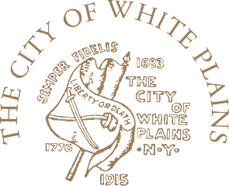

“THE BIRTHPLACE OF THE STATE OF NEW YORK”
OFFICE OF THE MAYOR

JUSTIN C. BRASCH
MAYOR
t: 914.422.1411
f: 914.422.1395

January 8, 2026
7 p.m.
https://us02web.zoom.us/j/4098438899
Agenda

- Approval of December Minutes
- Youth Board Chairman’s Report
- Report from the Mayor’s Youth Council
- Report From the Institute of Health – Helena Marescot
- Deputy Youth Bureau Director’s Report:
- Update on OASAS Grant Funding
- Forthcoming Training Opportunities
- Exploring AI Opportunities
- Youth Bureau Director’s Report
- 2025 Holiday Celebrations
- Grandpas United
- Clubmen Higher Aims Recruitment Program January 14, White Plains Public Library
- 2025 Unsung Heroes Celebration – January 29th, White Plains Public Library
- Grants Update:
- $50,000 Social Justice for Youth Program – Westchester County Youth Bureau
- $50, 000 Health and Fit for Life – Westchester County Youth Bureau
- $50,000 Boys Step Up Program – Westchester County Youth Bureau
- $29,000 Sports & Education Program – Westchester County Youth Bureau
- $29,362 Westchester County Youth Bureau
- $227,788 Westchester County Department of Mental Health (OASAS)
- Upcoming Events:
- Clubmen Higher Aims Recruitment, Wed., January 14, 6 p.m. WP Library
- MLK Jr. Youth Basketball Tournament, Sat., January 17, TDYCC, 12 p.m.
- Unsung Hero Awards Program, Thurs., January 29, 6 p.m. WP Public Library
- Report from White Plains Board of Education - Rosemarie Eller
- Report from Recreation Department – Commissioner Beth Bricker
- Report from White Plains Library - Tim Baird
- Report from White Plains Public Safety - Lt. August Fazzino
- Other
- Meeting Adjourn [Next Meeting: February 5, 2026]

255 Main Street • White Plains, New York 10601 www.cityofwhiteplains.com

